EMBRYOLOGY
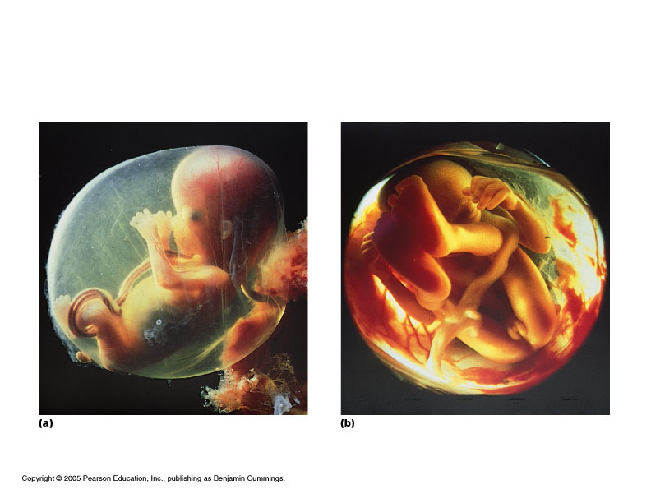

- Definition: the study of the origin and development of an organism
- Prenatal period: before birth
  - 38 weeks from conception to birth (average) “fetal” age
Traditional (artificial) division:
- “Embryonic” period: first 8 weeks
  - All major organs formed
  - “Fetal” period: remaining 30 weeks
  - Organs grow larger and become more complex
- 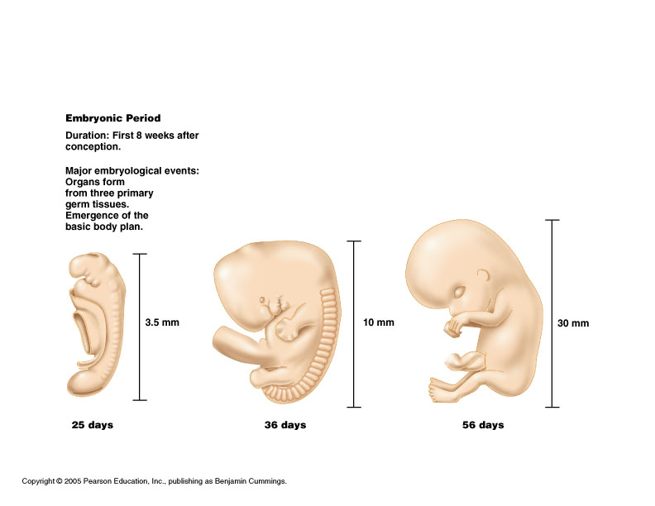
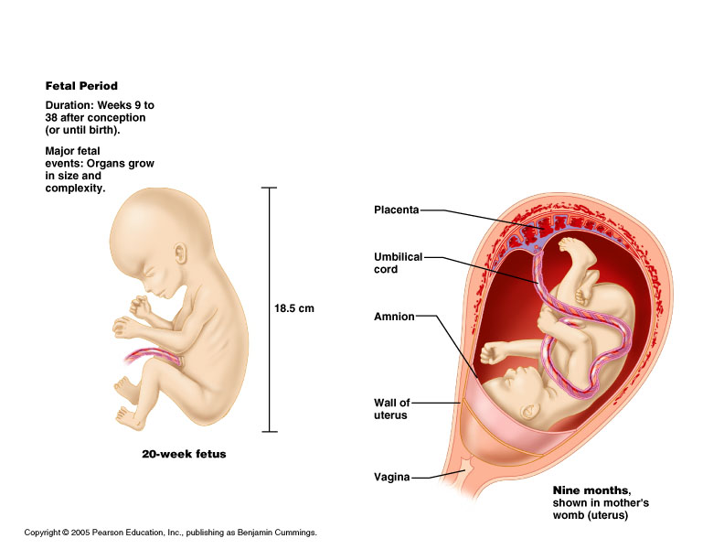

Fertilization to Implantation
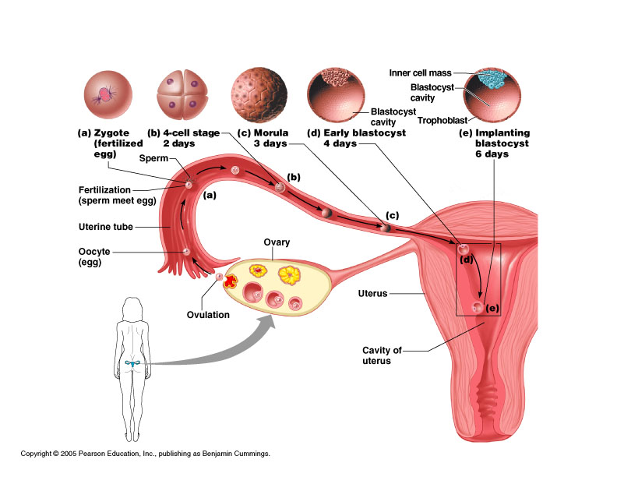

- Ovulation: egg released into the peritoneal cavity
- Travels down fallopian tube in which fertilization occurs
- At conception in fallopian tube, maternal and paternal genetic material join to form a new human life (zygote)
- Cell division occurs with travel down the tube and into the uterus
Week 1 post conception
- Zygote divides repeatedly moving down tube toward uterus (cleavage)
- The daughter cells are called blastomeres
- Morula: the solid cluster of 12-16 blastomeres at about 72 hours
- Day 4: late 60 cell morula enters uterus, taking up fluid becoming blastocyst
Blastocyst stage
- Two distinct types of cells
  - Inner cell mass: forms the embryo
  - Trophoblast: layer of cells surrounding the cavity which helps form the placenta
- Floats for about 3 days
- Implantation on about day 6 post conception
  - Trophoblast erodes uterine wall
  - Takes 1 week to complete
- If inner cell mass of a single blastocyst divides: monozygotic (identical) twins

HCG
- HCG is human chorionic gonadotropin
- It is produced by the trophoblasts starting on day 6
- hCG is a hormone
- hCG causes endometrium of uterus to grow and proliferate
- hCG prevents the menstrual cycle from occurring
- This is why a female misses her periods when she is pregnant

Week 2
- Inner cell mass divides into epiblast and hypoblast
- 2 fluid filled sacs
  - Amniotic sac from epiblast
  - Yolk sac from hypoblast
- Bilaminar embryonic disc: area of contact(gives rise to the whole body)
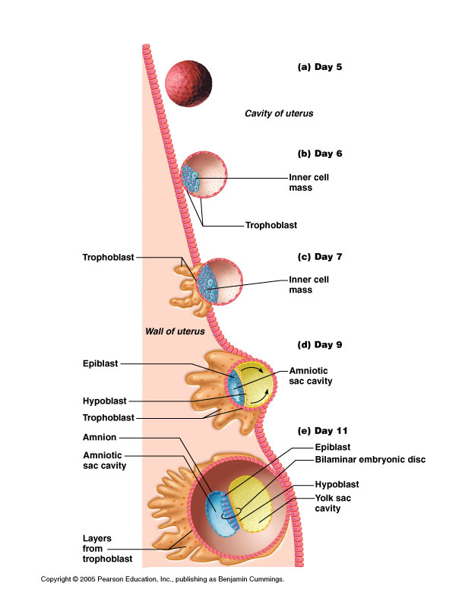
- Three primary “germ” layers: all body tissues develop from these
    - Ectoderm
    - Endoderm
    - Mesoderm

Formation of the 3 “germ” layers
- Primitive streak (groove) on dorsal surface of epiblast
- Grastrulation: invagination of epiblast cells
- Days 14-15: they replace hypoblast becoming endoderm
- Day 16: mesoderm (a new third layer) formed in between
- Epiblast cells remaining on surface: ectoderm
- “Germ” as in germinate, not germs
- Early specialization of cells
- Are precursors
- Ectoderm and endoderm are epithelial tissue (form sheets of tissue)
- Mesoderm is a mesenchyme tissue
  - Mesenchyme cells are star shaped and do not attach to one another, therefore migrate freely

Notochord
- Days 16-18
- Primitive node epiblast cells invaginate and migrate anteriorly with some endoderm cells
- Rod defining the body axis is formed
- Future site of the vertebral column
Neurulation
- Notochord signals overlying ectoderm
- There begins Formation of spinal cord and brain (neurulation)
- Neural plate to neural groove to neural tube: pinched off into body
- Closure of neural tube: begins at end of week 3; complete by end of week 4 (folic acid important for this step)
- Extends cranially (eventually brain) and caudally (spinal cord)
- Neural crest, lateral ectodermal cells, pulled along and form sensory nerve cells and other structures
- Mesoderm begins to differentiate
  - Lateral to notochord, week 3
  - Extends cranially and caudally (from head to tail or crown to rump)
- Division of mesoderm into three regions
  - Somites: 40 pairs of body segments (repeating units, like building blocks) by end week 4
  - Intermediate mesoderm: just lateral to somites
  - Lateral plate: splits to form coelom (“cavity”)
Divisions of the mesodermal lateral plate
- Somatic mesoderm: apposed to the ectoderm
- Splanchnic mesoderm: apposed to the endoderm
- Coelom in between will become the serous cavities of the ventral body cavity:
  - Peritoneal
  - Pericardial
  - Pleural

Major derivatives of the embryonic germ layers
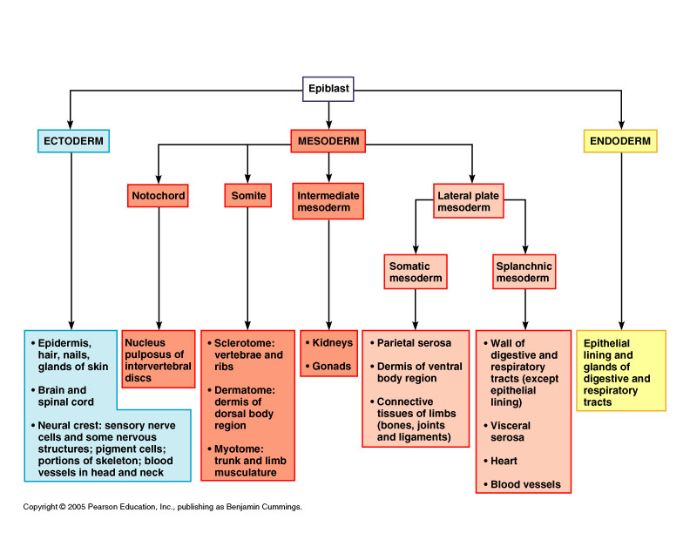

29 day embryo
(this is when the heart starts pumping, about 4 weeks or 1 month, ½ cm size)

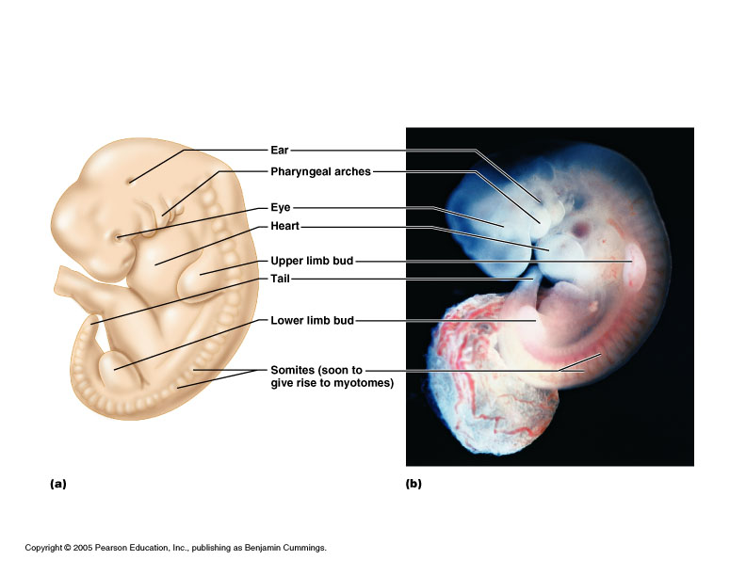

3 month fetus (6 cm) late 5th month(about 19 cm)




Questions
- Define the terms anatomy and physiology, and explain their relationship using an example of a human structure with its corresponding function.
- List, in order from least to most complex, the levels of structural organization, discuss the relationship between the levels, and name an example at each level.
- Define the term homeostasis, and name the manner in which homeostatic mechanisms are regulated. Then provide an example of a homeostatic mechanism in humans, and explain it fully, by providing a diagram followed by a complete essay explanation.
- Demonstrate what is meant by "anatomical position".
- Define various directional terms (i.e. superior, inferior, etc.), and compare different body parts using these terms (i.e. the elbow is proximal to the wrist).
- List both anterior and posterior anatomical landmarks (i.e. orbital, inguinal, etc.).
- Name the three major body sections (planes, cuts), and describe how each would be accomplished.
- Designate the five major human body cavities and name the organs within each on a human diagram.
- Describe the anatomical importance of the diaphragm muscle.
- Describe the nine regions of the abdominal area and the four quadrants of the abdominal area and list the major organs found within each.
- Distinguish between visceral and parietal serous membranes, and differentiate between pericardial, pleural, and peritoneal varieties.

TISSUES
I. Types of Tissues
A. Cells——tissues——organs——organ systems——organism
B. Tissue: Composed of specialized cells of the same type that perform a common function in the body.
- Epithelial tissue: Covers body surfaces and lines body cavities.
- Connective tissue: Binds and supports body parts. Muscular tissue: Moves the body and its parts.
- Nervous tissue: Receives stimuli and conducts nerve impulses.
- Cancers are classified according to the type of tissue from which they arise.
- Sarcomas: Cancers arising in muscle or connective tissue.

